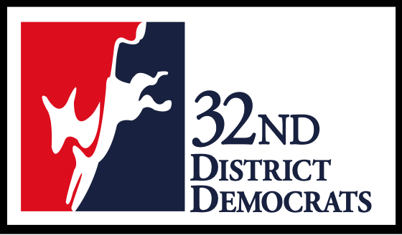

32nd Legislative District Democrats
2024 GENERAL Candidate Questionnaire
• Candidate Name

• Email address

• Campaign Email Address

• Campaign Phone

• Campaign Website

• Campaign Facebook page

• What position are you running for?

• Are you a Democrat?

• Have you ever been found in violation of a Public Disclosure Commission, Federal Election Commission regulation?

• Do you have a code of conduct for campaign staff and volunteers?

• Have you signed and submitted the 32nd LD Civility Pledge?

1. Briefly describe your education, employment, community and civic activity, union affiliation, and other relevant experience.

2. Please describe your background (education, employment, community and civic activity, union affiliation and political activity).

3. Have you ever met with an elected official regarding a concern you have?

4. Describe your history of involvement in Washington state politics, from the local to the state level.

5. What inspired you to run for this position and how would you evaluate your success?

6. What are the key challenges facing your jurisdiction and how do you plan to address these issues?

7. How will you ensure, as an elected official, you will be transparent and accountable to the voting public?

8. How will you involve all residents and engage all communities in the decision-making process?

9. How have you promoted an enduring environment of inclusivity, diversity, and equity?

10. List your most significant organizational and personal endorsements.

-------------------------------------------------
We have used the Washington State Democrats Platform and the 32nd LD Democrats Platform to prepare candidate questions. Please familiarize yourself with these documents.
----------------------------------------

CERTIFICATION: I hereby certify that, to the best of my knowledge, the provided information is true and accurate.

