Resolution Supporting Preserving of the Naval Hospital Chapel and Historic Surrounding Forest at Fircrest Through Creative Environmental Design Solutions for the Proposed Master Plan

WHEREAS in World War II, the United States Navy established our nation’s first Inter-denominational Naval Hospital Chapel on the site of the local Naval Hospital facility, the site now known as Fircrest School, which remains the only evidence of Shoreline’s participation in the WWII war effort; and

WHEREAS the Chapel and surrounding forest were envisioned by President Roosevelt and the Commanding officer, Captain JT Boone MD, as a place of healing and respite set aside upon the forested hillside where patients and staff were involved with tree planting as a healing outdoor exercise, as evidenced in the remarks by the President’s wife, First Lady Eleanor Roosevelt, when she represented the President at a commemoration of the Chapel grounds, and was honored and her visit commemorated by a tile inscribed with her name in the access garden; and

WHEREAS the Washington State Dept. of Archeology and Historic Preservation, (DAHP) has noted that the site is eligible for the National Register of Historic Places and has been landmarked as such by the Shoreline Historical Preservation Commission and support by King County in 2021; and

WHEREAS the State of Washington’s Dept. of Social and Human Services (DSHS) has presenting to the Shoreline community several proposals that would significantly impact the existing historic mature forest on the campus;

NOW THEREFORE BE IT RESOLVED, that the 32nd District Democrats, representing the citizens of Shoreline and the State of Washington, insist that DSHS, DNR and the City of Shoreline provide ample opportunity to present facts, documentations and scientific and historical analysis of all proposals and only permit a design that ultimately protect the historic forest and Chapel to the maximum extent possible; and

BE IT FURTHER RESOLVED, that this resolution shall be forwarded to the President of the United States; First Lady Dr. Jill Biden; the Washington State Congressional Delegation; the local, state offices of elected officials; the Secretary of the United States Navy; the U.S. Department of Veterans Affairs; the Washington State Department of Veterans Affairs; the numerous veterans associations in our area, including the Veterans of Foreign Wars; Disabled American Veterans; the American Legion; American Gold Star Mothers; U.S. Representative Mark Takano, Chair of the House Committee on Veterans’ Affairs; and environmental organizations requesting their support for the highest quality design for the historical significance of the Chapel and forest and for the residents, which also protects the air, water and wildlife habitat provided on site.

Submitted by Carolyn Ahlgreen, PCO
Adopted on May 4, 2022
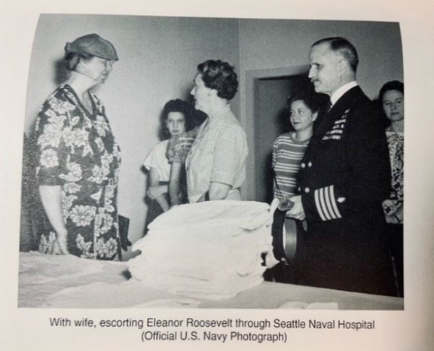
Photo from Book, The Presidents’ Doctor by Milton F Heller, Jr, Vantage Press, 2000

